MCM Had a Modulo Invention Development Kit on sale (198.99 retail) for $49.75.

The kit is modular in design, the modules are on the expensive side by themselfs, but since it was on sale it seemed like a good deal.

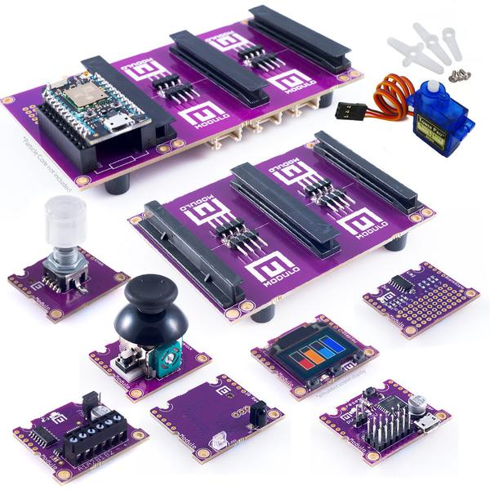

The kit comes with an Arduino “module” which can be programmed with the Arduino IDE, and is pretty straightforward to use. (It’s a UNO with less pins).

The kit also comes with a Particle Photon board, It was pretty obvious from the start that the KIT from MCM was an old(er) kit - the 1st clue was the Photon still had packing from when Particle was “Spark”.

Still, setup was pretty straightforward - at least to get the Photon to connect to the WIFI and the Particle Cloud. It wasn’t so straightforward after that.

The Particle Cloud doesn’t even show which firmware is on the device, so it needs to be updated. There is a lot of mis-information for updating the firmware to something the cloud can use. But here are the documents I finally found that were able to get me online, and writeing code.

The Photon needs to be in DFU mode, and you need the DFU Util installed on your machine.

You may or may not need the Partical-CLI tools too (I didn’t need them, and they were a little bit of a pain to install with Linux) But at least some part of the instructions say you need them.

SO Prep-Work before the real work….

1. Install Node.js and nodejs-legacy (Which wasn’t in any documentation, my system told me I needed it, and then things started working)

sudo apt install npm

sudo apt install nodejs-legacy

Before we install the Particle-CLI tools we need to change the permissions of the node directories.

<https://docs.npmjs.com/getting-started/fixing-npm-permissions>

This boils down to finding where npm is installed (typically /usr/local) and chaning the ownership to your user name.

sudo chown -R username /usr/local/{lib,bin,share}

<https://docs.particle.io/guide/tools-and-features/cli/photon/>

Now we install Particle-CLI - this step failed for me, and I had to use the GITHUB repositories. BUT It may have failed because I didn’t have nodejs-legacy installed. So try it first.

npm install -g particle-cli

(IF it fails…..)

This is what I did…. Made a new directory in my home folder

mkdir particle

cd particle

git clone <https://github.com/spark/particle-cli.git> (Which creates a folder particle-cli)

cd particle-cli

npm install

(In the long run I didn’t need these tools, and I spent a couple of hours trying to figure out just why particle-cli wasn’t installing, All of the documents, and it boiled down to a few simple commands above)

2) YOU will need the DFU-UTIL so you have to install this, luck this is easy to.

sudo apt-get install dfu-util

<http://dfu-util.sourceforge.net/> for more information, which does tell how to get the tool for Windows and Mac OSX

3) You need the 0.4.6 firmware for the Photon - At least this is what I found, and what worked for me (Current Firmware is 6.2, so you will need to upgrade later once a good current firmware is on the device it’s easy to upgrade).

<https://community.particle.io/t/photon-troubleshooting-guide-as-of-firmware-v0-4-6/16042>

You will need the two firmware binaries - yes this is a multi-step way to update the firmware, but seemed to work so we will go with it.

To upgrade your Photon, follow the instructions below:

* Download the proper firmware binaries for the Photon linked below:
  + [Part1319](https://github.com/spark/firmware/releases/download/v0.4.6.1/system-part1-0.4.6-photon.bin)
  + [Part2257](https://github.com/spark/firmware/releases/download/v0.4.6.1/system-part2-0.4.6-photon.bin)

The photon needs to be plugged into the computer, and set up for DFU mode.

<https://docs.particle.io/guide/getting-started/modes/photon/#dfu-mode-device-firmware-upgrade->

### **DFU MODE (DEVICE FIRMWARE UPGRADE)**

If you wish to program your Photon with a custom firmware via USB, you'll need to use this mode. This mode triggers the on-board bootloader that accepts firmware binary files via the [dfu-utility.](https://s3.amazonaws.com/spark-assets/dfu-util-0.8-binaries.tar.xz) (Note: Some users reported issues with dfu-util on a USB3.0 ports on Windows. Use a USB2.0 port if the USB3.0 port doesn't work.)

Installation tutorial can be found [here.](https://docs.particle.io/guide/tools-and-features/cli/)

And a usage guide [here.](https://docs.particle.io/reference/cli/)

To enter DFU Mode:

1. Hold down BOTH buttons
2. Release only the RESET button, while holding down the SETUP button.
3. Wait for the LED to start flashing yellow (it will flash magenta first)
4. Release the SETUP button

(Windows may need drivers, linux and Mac do not)

My firmware binaries downloaded to my Downloads folder, so I changed to that directory.

Now type

dfu-util -d 2b04:d006 -a 0 -s 0x8020000 -D system-part1-0.4.6-photon.bin

Once it’s done your Photon should still be in DFU mode you’ll want to flash the 2nd part…

dfu-util -d 2b04:d006 -a 0 -s 0x8060000:leave -D system-part2-0.4.6-photon.bin

This will take a while, and depending on if you were able to connect to the cloud before, or if the device still needs setup will depend on what LED Color you will see flashing next, and what you need to do for the next step.

Once you are on the cloud, if you open the Blink LED sketch, and select a newer firmware from your device list - and upload the sketch to the device it will update the firmware first (and may take a little while).

I went from 0.4.6 to 0.5.3 to 0.6.2.

So after spending hours attempting to get this thing to work, it was really pretty simple once you have the steps in the right order.

More Getting Started with Particle

<https://docs.particle.io/guide/getting-started/start/photon/#step-1-power-on-your-device>